Chapter 13

2)

a. The fact table components are year, region, agent and product.

b. The dimension tables are also year, region, agent and product.

c.

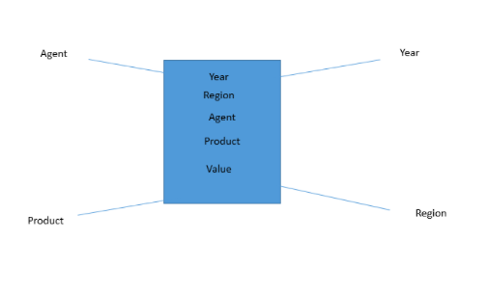

d.

Year Dimension: Year_ID

Region Dimension: Region_ID, Region_Name

Agent Dimension: Agent_ID, Agent_Name

Product Dimension: Product_ID, Product_Description, Product_Price

e.

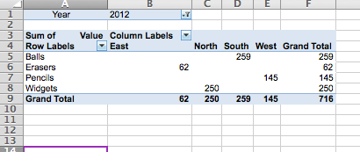

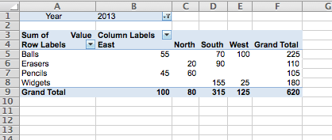

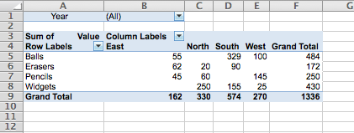

f.

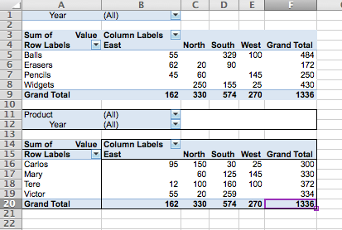

g.

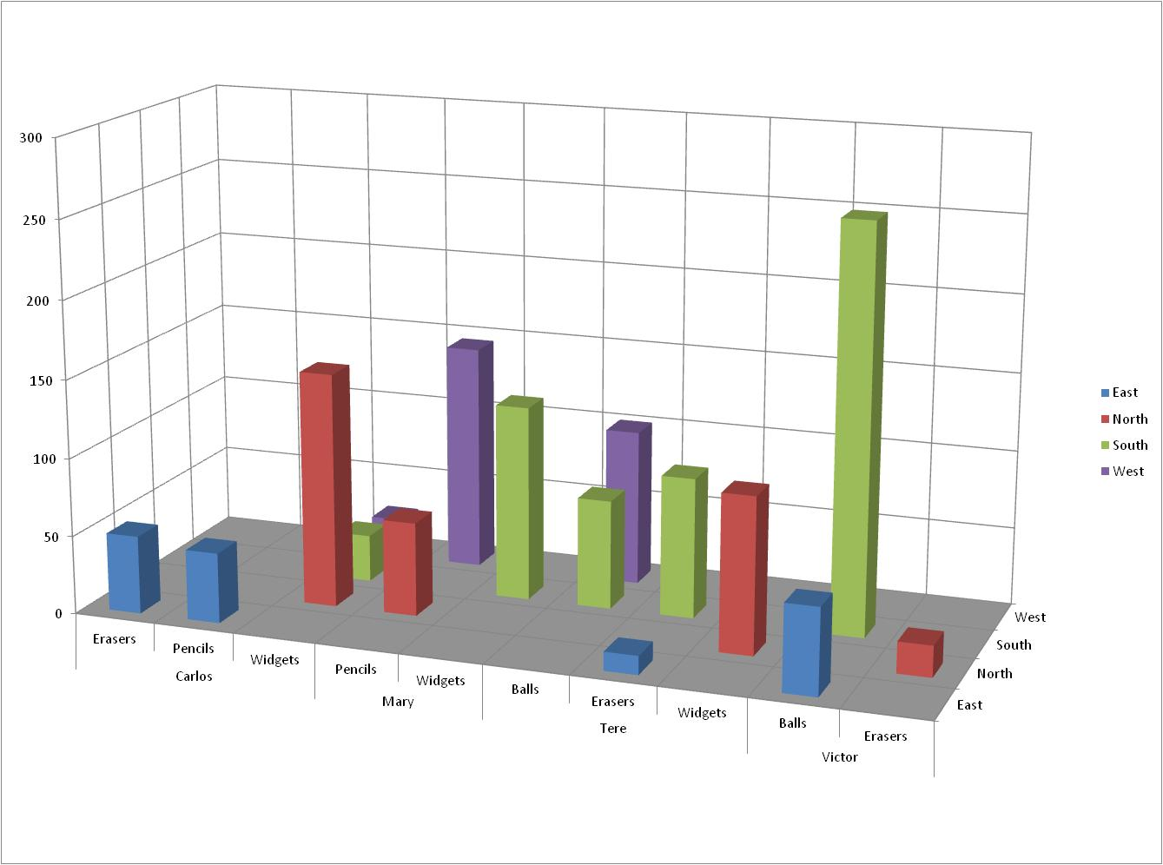

3)

a.

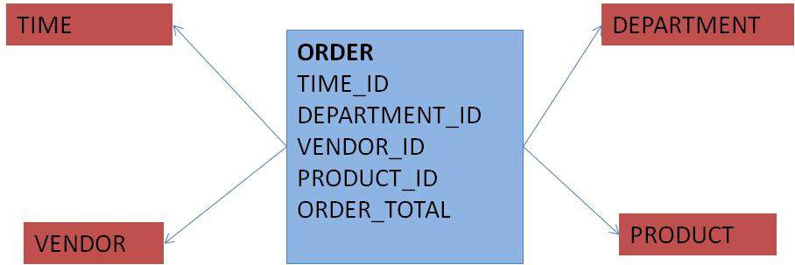

b.

The dimensions are TIME, DEPARTMENT, VENDOR, and PRODUCT

5)

SELECT CUS_CODE, P_CODE, SUM(SALE_UNITS*SALE_PRICE) AS TOTSALES

FROM DWDAYSALESFACT NATURAL JOIN DWPRODUCT NATURAL JOIN DWCUSTOMER

GROUP BY ROLLUP (CUS_CODE, P_CODE)

ORDER BY CUS_CODE, P_CODE;

6)

SELECT CUS_CODE, TM_MONTH, P_CODE, SUM(SALE_UNITS*SALE_PRICE) AS TOTSALES

FROM DWDAYSALESFACT NATURAL JOIN DWTIME NATURAL JOIN DWPRODUCT NATURAL JOIN DWCUSTOMER

GROUP BY ROLLUP (CUS_CODE, TM_MONTH, P_CODE)

ORDER BY CUS_CODE, TM_MONTH, P_CODE;